Name of Student: Husam Ali Abdalla Nour | PRN:25070122086
Semester: III | Year : AY 2026-27
Subject: Programming with Java
ASSIGNMENT No : 18
TITLE : Java GUI Button Event Handling
Problem Statement
Write a Java GUI program to demonstrate button click event handling.
Learning Objectives
To implement button click events using Java event handling mechanisms.

Programme
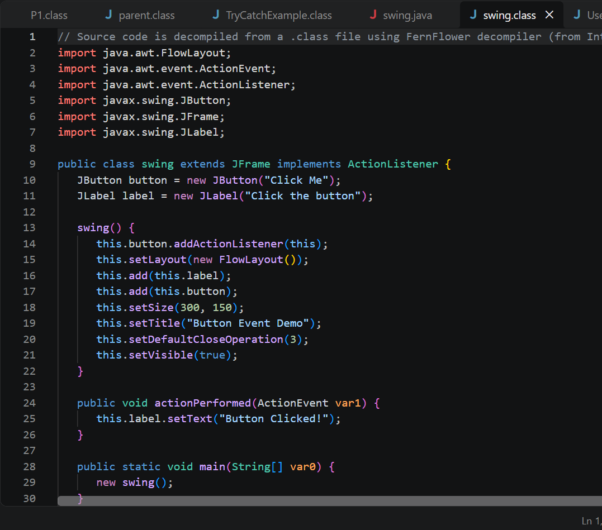
Output
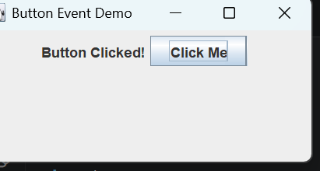
Practice questions
- Create a GUI calculator where buttons perform addition and subtraction.
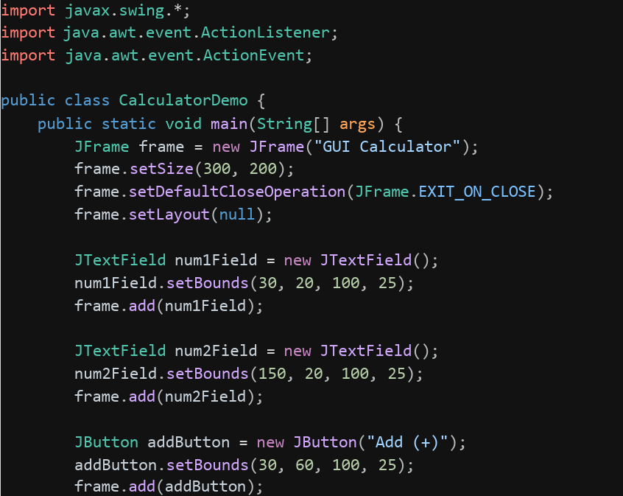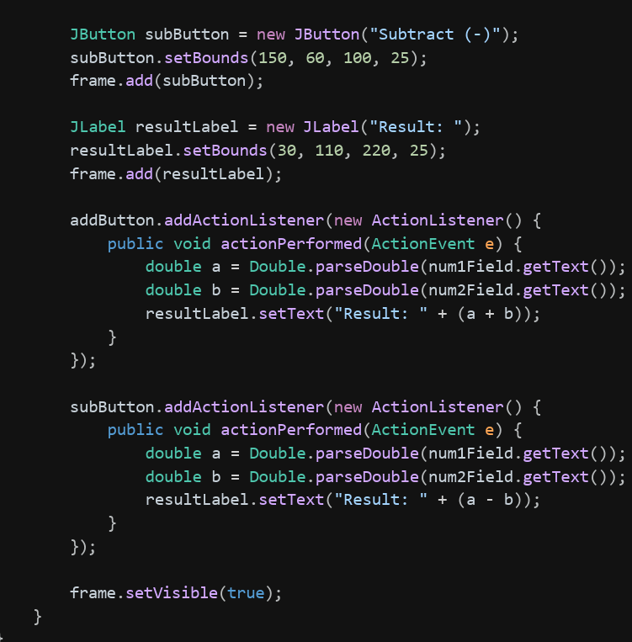
Output
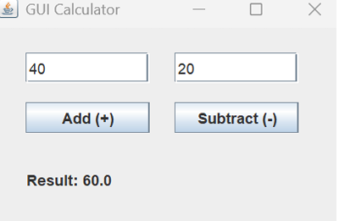
- Create a Bank Balance Calculator GUI application using Java Swing where the user enters the initial balance and transaction amount. Use buttons to perform addition (deposit) and subtraction (withdrawal) and display the updated balance.
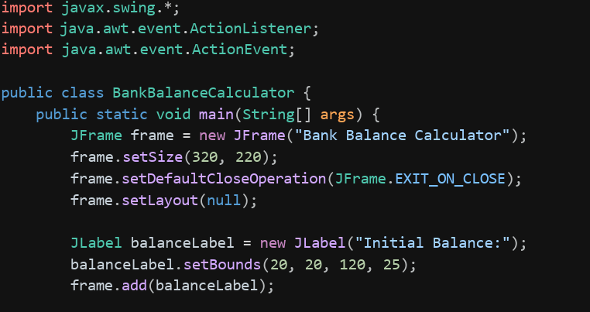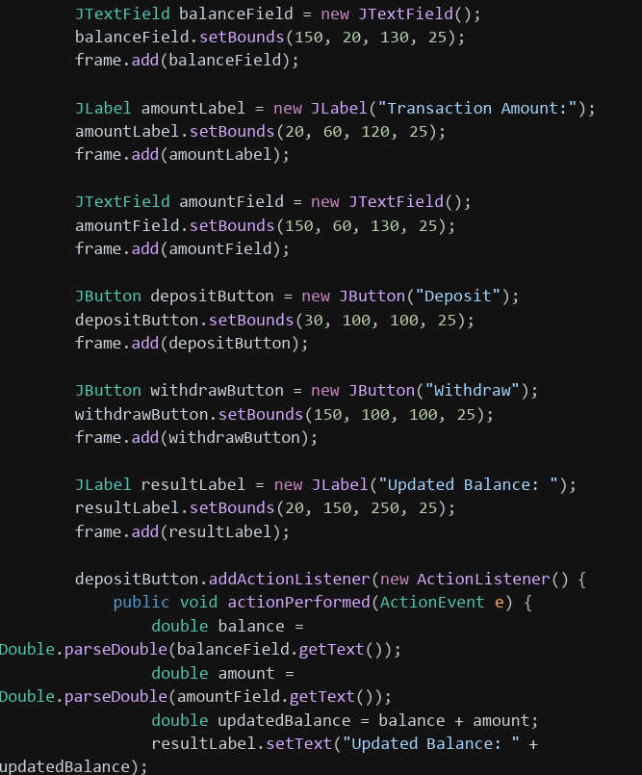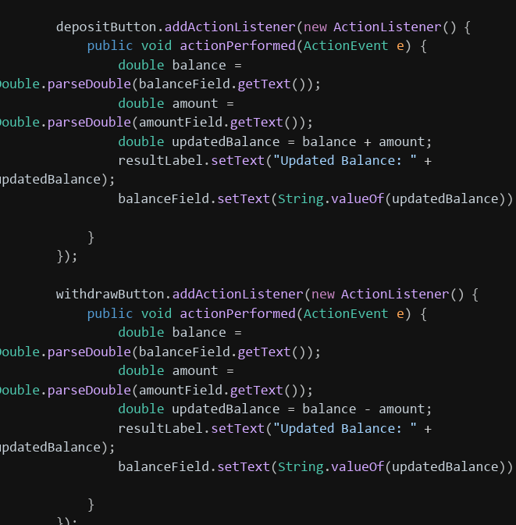
Output
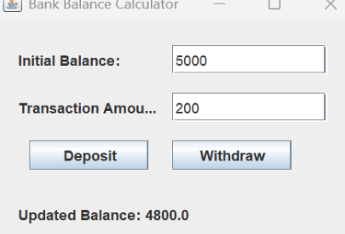
Conclusion
Conclusion Event handling is what makes a GUI interactive — without it, buttons would just sit there. Using ActionListener and its actionPerformed() method, a Java Swing application can respond immediately to user actions like button clicks, separating the interface layout from the logic that processes user input, as shown in the calculator and bank balance examples.

